Introduction

This is the statement of work document for bus ticket issuing system built by us. In this document we have the procedure of ticket issuing for passenger and for bus authority we have a system in our software where they can see how many ticket are available and how much money is collected from sold ticket. We will use waterfall model to build the software. Our project has an audience who travelled by bus daily.

Proposed Solution

our online ticketing software is built for purchase ticket,booking ticket and it also has refund policy for failed transaction.it has discount for regular users.it is built for various types platform(windows,mac,linux,android(web baesd)).passenger login to the system and buy their expected ticket without any harrasement.it has a verification system.if you purchase or booking your ticket the system will verify you by your name,email address ,phone no,& your photo and user_id.you purchase your ticket in once in one day.without this verification you would not buy your ticket.

refund policy

failed transaction

verification

purchase/booking

ticket

online ticketing

Block diagram for proposed solution

Project objective

My project object is to make a cheap and a user friendly for passenger to purchase ticket

Feature set

In my software I have

* Passenger can select source and destination
* Rent will be counted by per km of source to destination
* One person can issue 3 ticket
* Info for passenger
* Vacancy on bus
* Distance from one terminal to another
* Transection software
* Travel time duration
* Number of bus terminal
* Database for authority

Requirement

# Passenger

1. Ticket purchasing software: In the ticket issuing tool the passenger will need that kind of software which will have the map as data so the passenger can choose his destination where he wants to go from where his current location is. There will be classic, business class seat passenger. There are 10 terminal so the passenger can choose specific 1 bus terminal .The hire should be fix as per km. In this machine we also need card reading software it will check the card is valid or not or else have sufficient budget to purchase a ticket. If the customer enter a wrong password the system should inform the passenger the password is invalid .It also should have bill identifier software whatever is it fake or real or else tear .if it is torn it should also have software to inform the customer the bill is no usable insert another bill. It also need a software to count the distance from the current location of passenger. IT also should have where his/her desired bus is. In issuing ticket system there will be a function in our software to show the passenger that how many seat are vacant in the bus. After finishing all the process the passenger will be given 12 hours to cancel the ticket and get the money back. After confirming the passenger will be given a ticket like card which he can recharge for further journey.

Authority

1.For authority in my software I have the function which will show the number of total ticket sold and how much money collected, it will also show how many tickets are left and how many passenger are on board. For authority in my software I have password verification if they give wrong password they will show invalid .After giving 3 times wrong password the higher authority will be informed. And his id will be locked.

Diagram

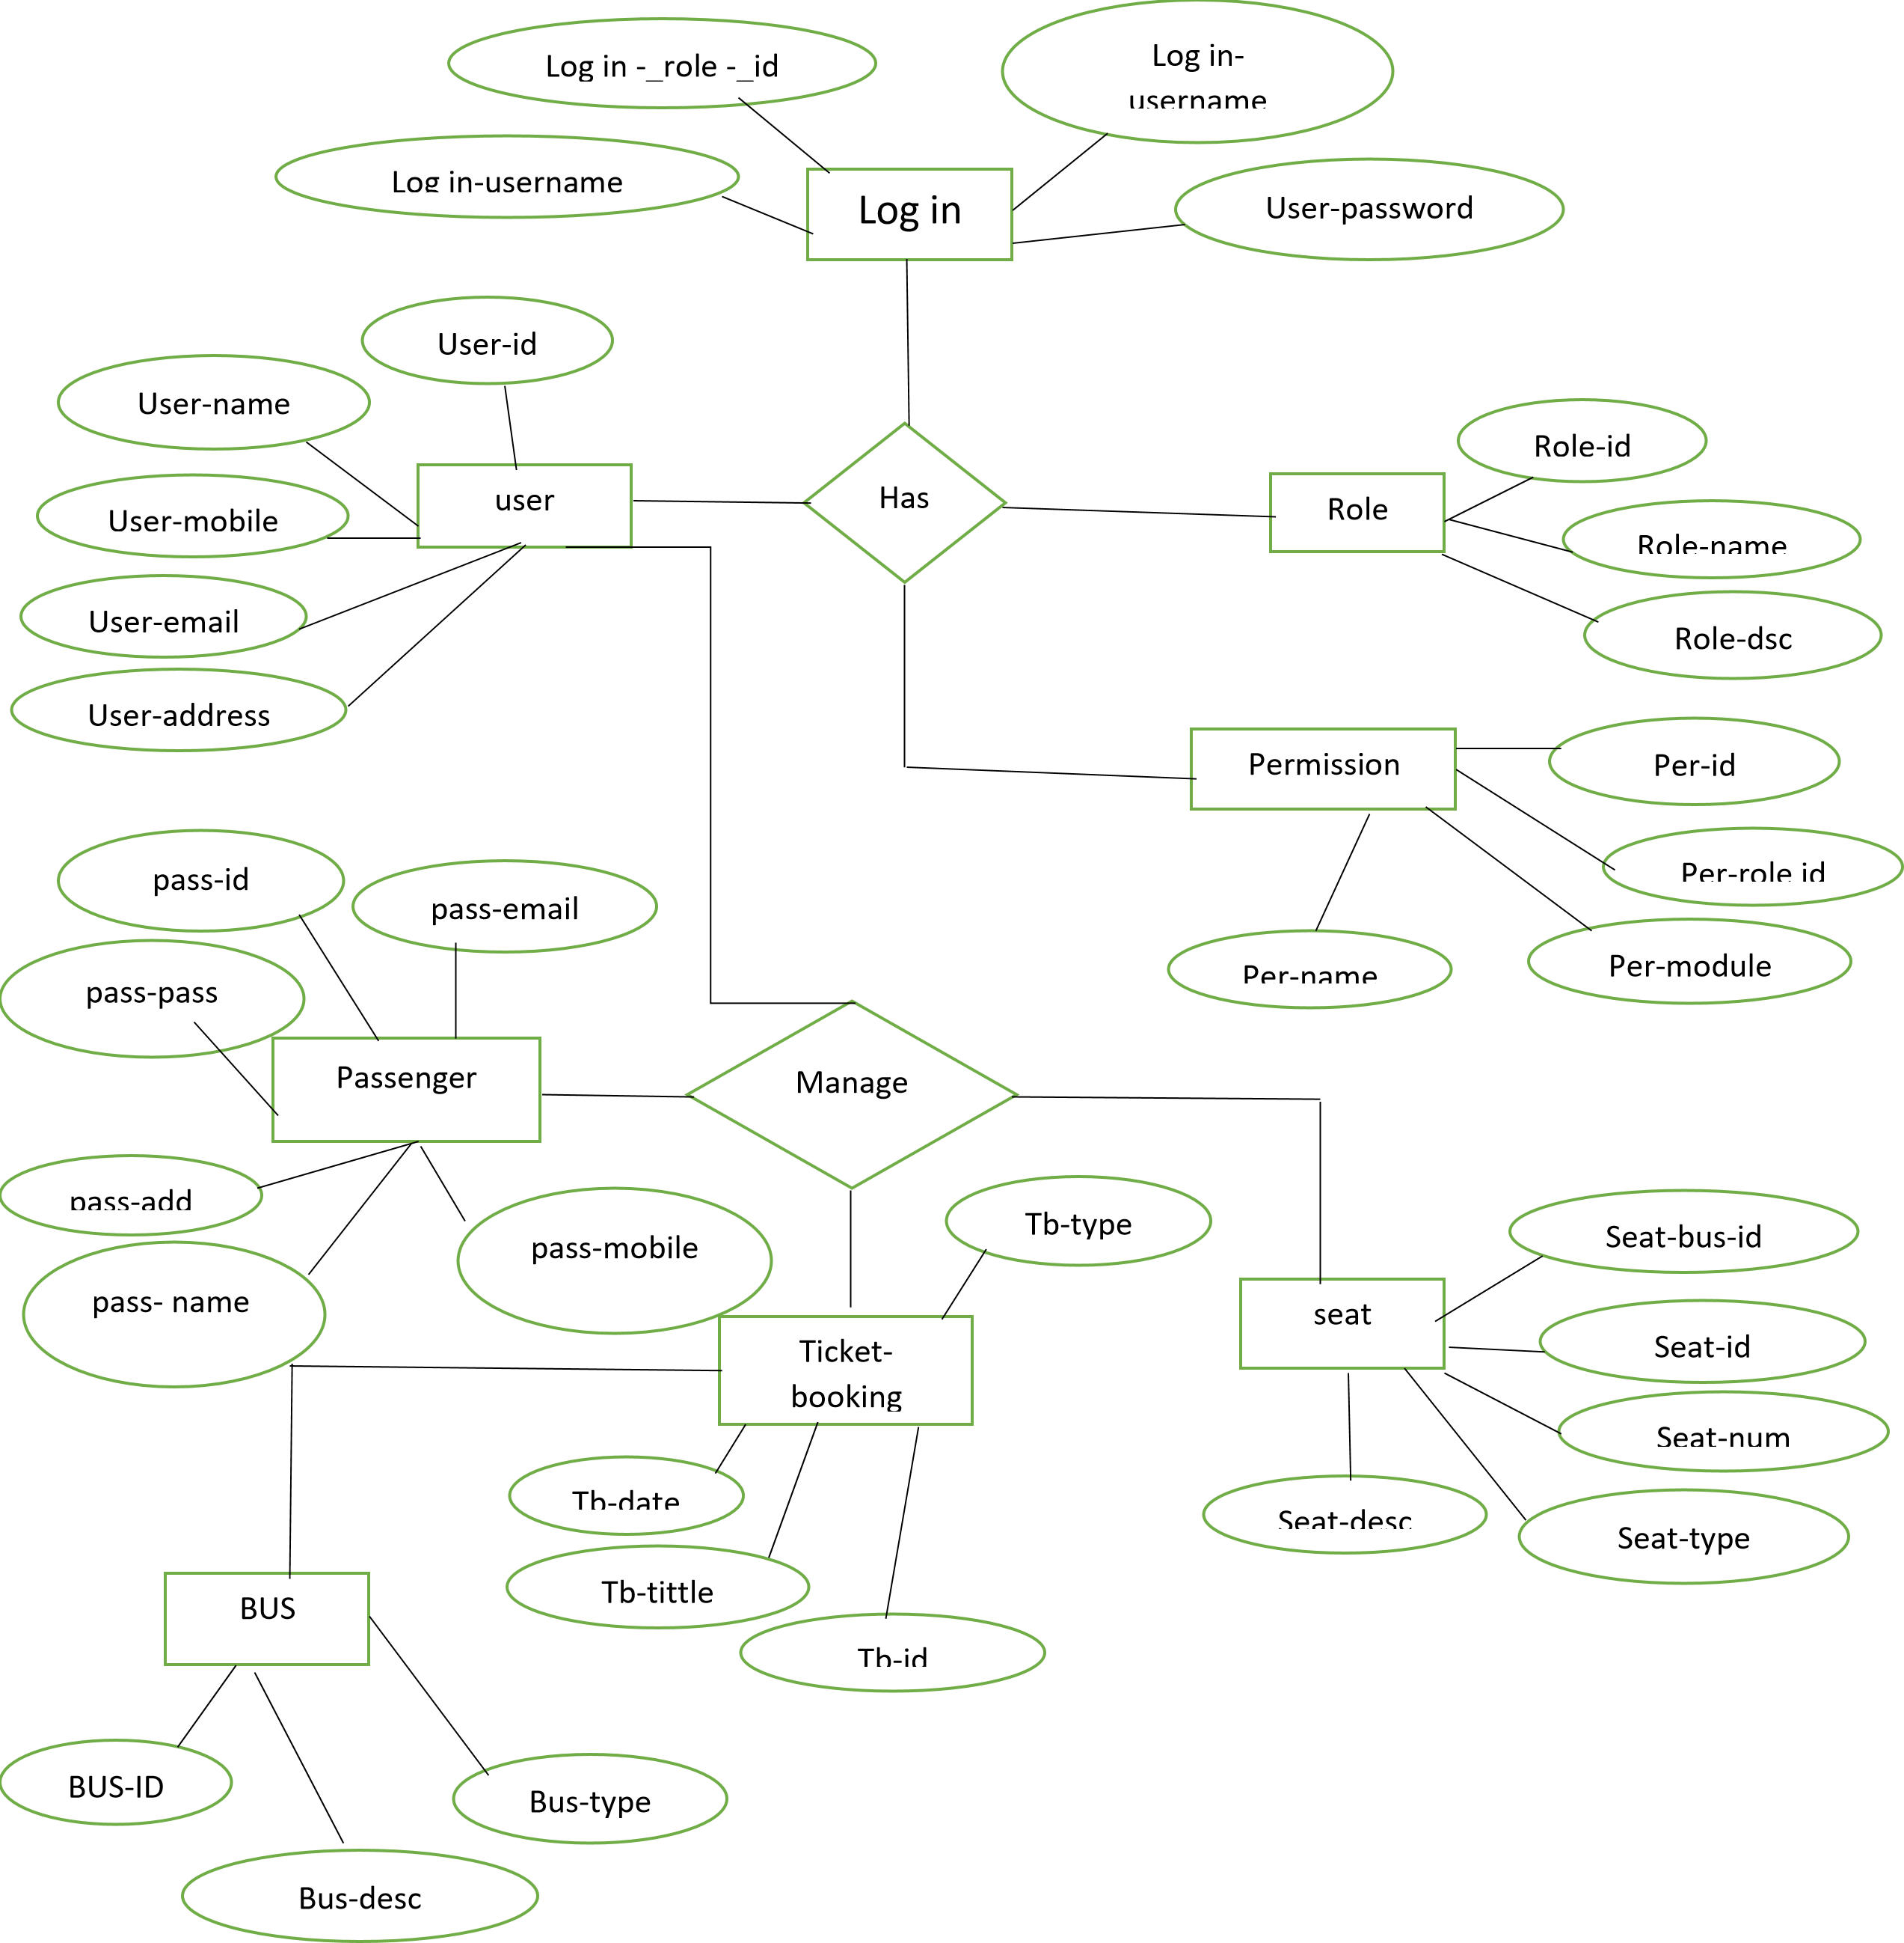

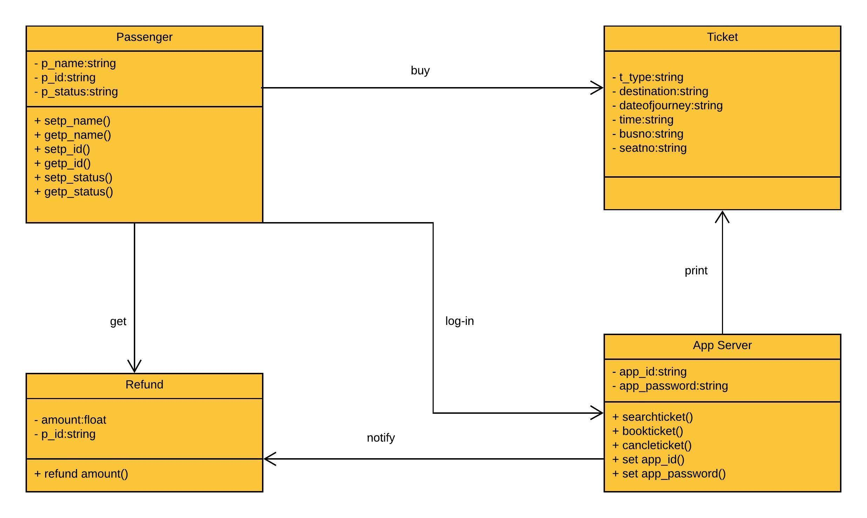

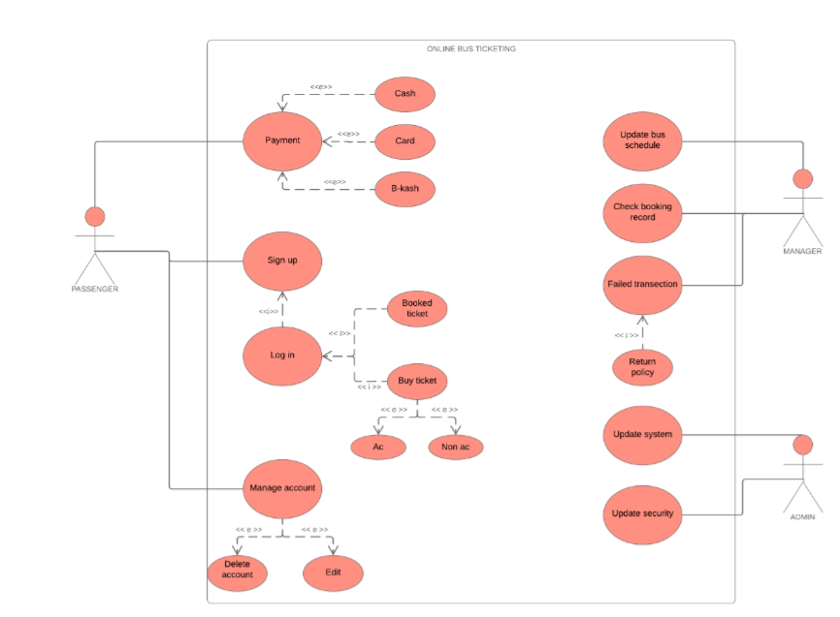

2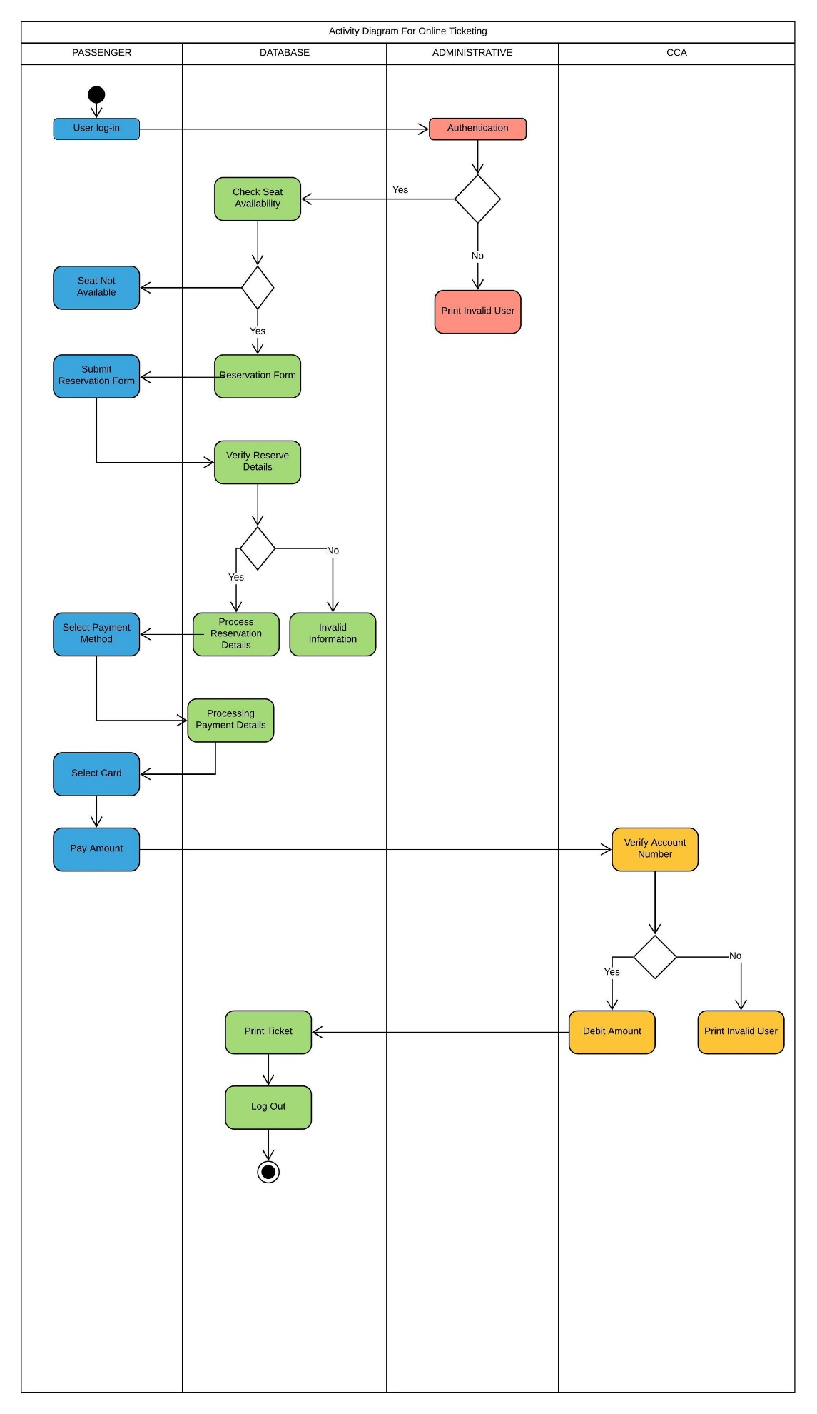

SDLC

3.1 Process model

* There are many development process model in SDLC. We choose waterfall model to build the software. Cause we have clear and well-defined requirement.
* We all know waterfall model is sequential model which is done step by step. In this sdlc process model the requirement should be well defined. Which we have. We have less requirement and those are clear.

3.2 project role identification

We all know there are various role in project. In our software development we may have many role in project to be done such as project manager, developer, requirement analyzer, tester, market analyzer etc. our group has 4 members

* Omer Fahim Fatemi (Project manager, requirement analyzer)
* Saddat (UML designer:star uml, market analyzer)
* Injmam (developer: php, html, css, bootstrap, javascript, mysql)
* Jahid (tester:tools used selenium, test studio )